**Pre-Requisite:**

* Java 1.6 and higher.
* Cygwin with open ssh installed.
* ssh daemon in Cygwin.

**Download Hadoop:**

Download latest hadoop version from here [Hadoop](http://www.apache.org/dyn/closer.cgi/hadoop/common/).

Copy the downloaded file to a folder. Here I placed in below folder

|  |
| --- |
| C:\java |
|  |

**Configuring Hadoop single Node:**

Go to the below path

*C:\java\hadoop-2.0.1-alpha\etc\hadoop*

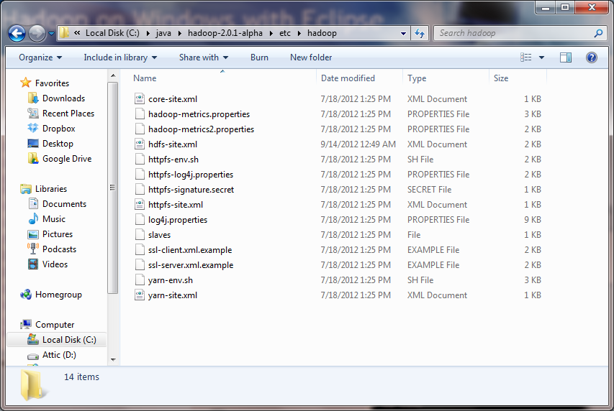

Open ***hdfs-site.xml***

The content of the file should be as below

|  |
| --- |
| <property>  <name>fs.default.name</name>  <value>**hdfs://localhost:9100**</value>  </property>  <property>  <name>mapred.job.tracker</name>  <value>**localhost:9101**</value>  </property>  <property>  <name>dfs.replication</name>  <value>**1**</value>  </property> |

The above configuration sets up the hdfs node in the localhost machine in the provided port.

**Format the name node in hdfs:**

* Open a new Cygwin window.
* Execute the following commands:

|  |
| --- |
| cd c:/java/hadoop-2.0.1-alpha  mkdir logs  bin/hdfs namenode -format |

While executing the command if you get below error.

Executexecute below command for setting java_home path.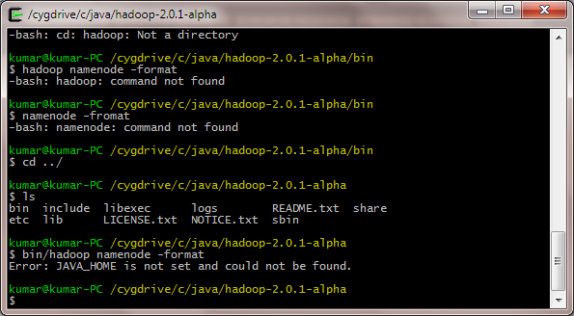

|  |
| --- |
| export JAVA_HOME="/cygdrive/c/Program Files/Java/sjdk1.7.0_02/" |

You should get output similar to below screen for successful execution of command

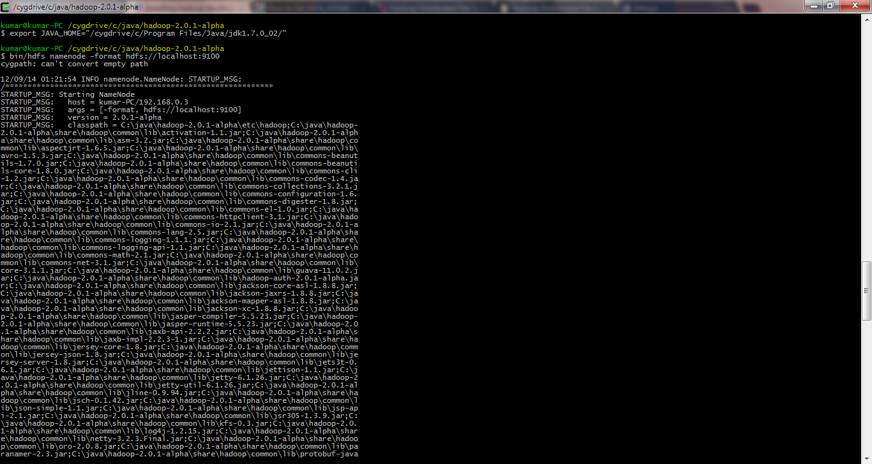

**Start the local hadoop cluster:**

1. Start the **namenode** in the first window by executing:

cd C:/java/ hadoop-2.0.1-alpha  
bin/hdfs namenode

1. Start the **secondary namenode** in the second window by executing:

cd C:/java/ hadoop-2.0.1-alpha

bin/hdfs secondarynamenode

1. Start the **job tracker** the third window by executing:

cd C:/java/ hadoop-2.0.1-alpha  
bin/ mapred jobtracker

1. Start the **data node** the fourth window by executing:

cd C:/java/ hadoop-2.0.1-alpha  
bin/mapred datanode

1. Start the **task tracker** the fifth window by executing:

cd C:/java/ hadoop-2.0.1-alpha  
bin/ mapred tasktracker